Mylia Garner

Tonya Wertz-O

English 1102

April 2, 2014

Experiment or Death

My research inquiry was to find information on the deadly medical experiments in the Holocaust. I chose this because I am a pre-kinesiology major and I wanted to find out about events that occurred in the holocaust that had to do with the body.
During the Holocaust there was many medical experiments conducted on the concentration camp inmates, over 25 experiments. The experiments weren’t the average experiments you would do to people. (The Experiments.) The victims went through horrible pain, mutilation, and life long disabilities and in many cases death. Some of the experiments were high altitude, freezing, sulfanilamide, twins, poison, tuberculosis, phosgene, bone, muscle and joint transplantation, sterilization, artificial insemination and seawater. (The Experiments.) Karl Brandt and Josef Mengele preformed most of these experiments. They both were sentenced death (executed) of being guilty of war crimes at the “Doctors Trial.”

The Doctors

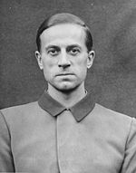

Dr. Karl Brandt was Hitler’s personal physician. He was also the appointed Reich Commissioner for Sanitation and Health. Brandt was ranked to have the highest authority. Since Brandt was in charge we was forced to give instructions to the Nazi medical team to torture the concentration camp victims. (Holocaust - Medical Experiments)
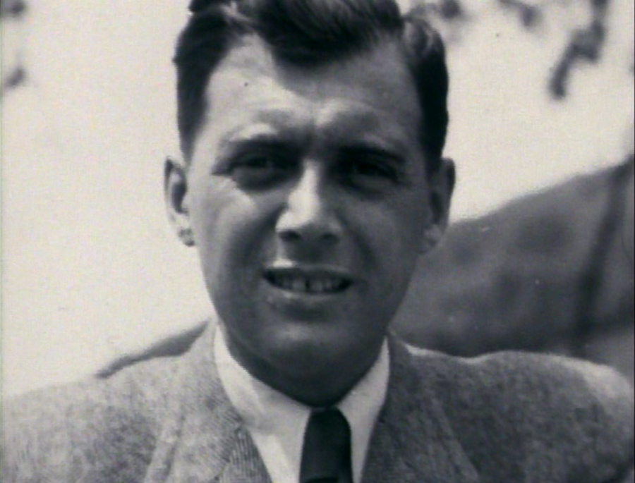

Dr. Joseph Mengele also known as the Angle of Death not for his experiments but for being the chief provider for the gas chambers and the crematoria. With these inventions he was able to kill hundreds of people at one time. (United States Holocaust Memorial Museum.) One survivor said, “He had the look that said ‘I am the power.’” (Josef Mengele, Angel of Death.) Mengele was known as the man in charge but wasn’t ahead of Karl Brandt because he had just got his doctors degree in 1937 and that was the same year he joined the army.
Experiments
While many experiments occurred I’m only going to tell you about a few. The first one is the Sulfanilamide Experiment. From my understanding the Nazi Army wanted to do an experiment that displayed what a solider may go through during combat. So they try to stimulate an inflicted battle wound. (The Experiments.) Nazi’s took the leg of Jadwiga Dzido who survived the war from Ravens ruck. They slit open her leg and placed bacteria, dirt and pieces of glass in the open wound. Afterward they treated the wound with sulfanilamide drug. (The Experiments.) This drug is just an antibacterial drug. Meaning that it didn’t take away any of the pain Dizido was going through.

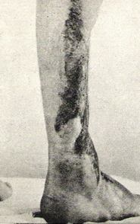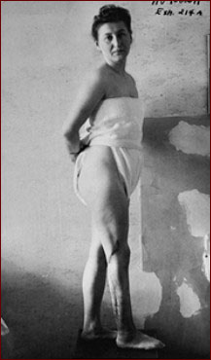

Another horrifying experiment would be the bone, muscle and joint transplantation. The Nazi’s thought that they could take libs from one body and attack them to another body and they would work fine but of course that’s not capable of happening. (The Experiments.) They amputated legs and arms from some of the prisoners and attached those body parts that have been amputated and tried to attach them to other prisoners. It didn’t just occur three or four times they had useless attempts to try to get this to work. (The Experiments.) To make it “look good” they would just remove some to “study” the bones, muscles and nerves in these body parts. These prisoners suffered excruciation pain and permanent disability for the rest of their lives. (The Experiments.)

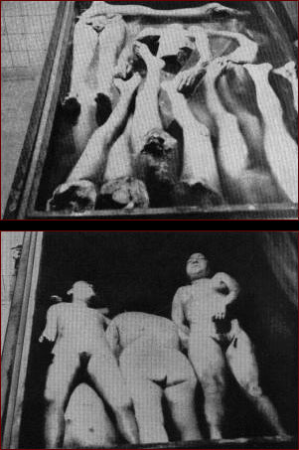

The last experiment I’m going to talk about is the twins of the holocaust. Out of 1000 pairs of twins on 200 pairs survived these experiments. Dr. Josef Mengele were so obsessed with twins, more because he was one himself. During all these experiments all he wanted to find out the secrets to multiple births. Mengele and his followers would inject chloroform to the heart of they victims. (The Experiment.) Each experiment were different Mengele would put chemicals on their skin, put them in freezing baths, detach body parts, injected over 150 chemicals into their bodies and etc. (Josef Mengele, Angel of Death.) It’s crazy of how these kid’s lives had to end. Some twins saw everything that happened to their brother or sister and had to live the rest of their life experiencing that first hand. One survivor Moshe Offer, recalled his brothers dead:

“Dr. Mengele had always been more interested in Tibi. I am not sure why –
perhaps because he was the older twin. Mengele made several operations on
Tibi. One surgery on his spine and left my brother paralyzed. He could not walk anymore. Then they took out his sexual organs. After the fourth operation, I did not see Tibi anymore. I cannot tell you how I felt. It is impossible to put into words how I felt they had taken away my father, my mother, my two older brothers – and now, my twin…” (Josef Mengele, Angel of Death.)
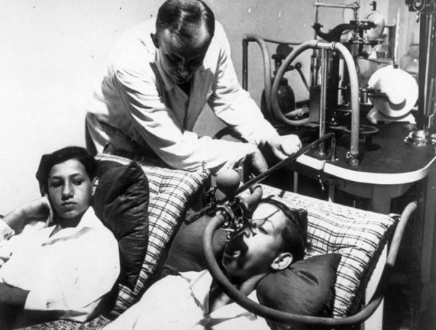

As you could only imagine how horrible these experiments were, how could anybody do this to a human being and not think of ones self and how they would feel about it. It was almost as if the conductors of the experiments had no feeling that they endured and loved the crying and screaming of people. I don’t know how this was possible. I realize yes they wanted to destroy the Jews but why torture them too. Know one will ever understand what went through the Nazi’s mind but luckily because the world knows the facts this will never occur ever again.

Works Cited
Amputated Limbs. N.d. PBS. Web. 2 Apr. 2014. (picture)
Bülow, Louis. "Holocaust - Medical Experiments." Holocaust - Medical Experiments. Deathcamps.info, n.d. Web. 31 Mar. 2014.
Bülow, Louis. "Josef Mengele, Angel of Death." Josef Mengele, Angel of Death. N.p., n.d. Web. 31 Mar. 2014.
"Josef Mengele." United States Holocaust Memorial Museum. United States Holocaust Memorial Council, 10 June 2013. Web. 31 Mar. 2014.
Karl Bradt as a Defendant in the Doctor's Trial. N.d. Wikipedia. Web. 2 Apr. 2014. (picture)
A Leg of One of the Seventy-four Polish Victims Subjected to Medical Experiments in the Ravensbrück Concentration Camp. 2010. Women in European History. Web. 2 Apr. 2014. (picture)
Ravensbruek on Dizdo. N.d. PBS. Web. 2 Apr. 2014. (picture)
Tyson, Peter. "The Experiments." PBS. PBS, Oct. 2000. Web. 02 Apr. 2014.
Verschuer, Otmar F. Male-twins-undergoing-spirometry. N.d. Josef Mengele and the Twins at Auschwitz. Web. 2 Apr. 2014. (picture)
World, Kakudan. Joseph Mengele. N.d. DeviantArt. Web. 2 Apr. 2014. (picture)

